This project is generously funded by [IES VLL](https://ies.ed.gov/funding/grantsearch/details.asp?ID=1804) ([Virtual Learning Lab](https://virtuallearninglab.org/)), [Schmidt Family Foundation](https://tsffoundation.org/), [UF AI Catalyst](https://research.ufl.edu/finding-funding/internal-competitive-funding.html), and [UFII Seed Grant](https://informatics.research.ufl.edu/ufii-programs/seed-funds.html). To support online learners of STEM at a large scale, educational researchers have adopted artificial intelligence (AI) and learning analytics (LA) techniques such as machine learning (ML) to improve teaching and learning processes. However, limited attention has been paid to the fairness of intelligence in educational settings that could enlarge inequality in education. In this project, we aim to explore methods and strategies to evaluate and mitigate AI bias as well as explain AI decision-making to support students in Algebra Nation, an online math learning platform with about 1M active students. Specifically, we have explored different strategies to enhance AI fairness for education in different tasks such as academically at-risk prediction, peer recommender for help-seeking, and conversational AI for socio-emotional support. Check our [promotional video](https://youtu.be/392JuuIPX4Q).

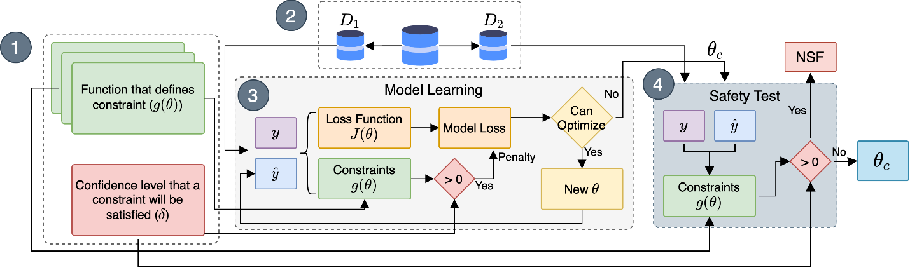

Fair logistic regression

SafeMathBot mechanism

1. (b)User interface of teachers’ dashboard powered with fair prediction

|  |  |
| --- | --- |
| C:\Users\wing\Dropbox (UFL)\A NEXT IDEA\1 UF Research Group\Marketing Assets\peer_recommender.jpg |  |
| User interface of fair peer recommender | User interface of teachers’ dashboard powered with fair prediction |

**Relevant publications**

Check out the papers published in [British Journal of Educational Technology](https://bera-journals.onlinelibrary.wiley.com/doi/10.1111/bjet.13227), [Distance Education](https://www.tandfonline.com/doi/abs/10.1080/01587919.2021.2020619), [ACM Learning Analytics and Knowledge (LAK)](https://dl.acm.org/doi/10.1145/3448139.3448200), and [ACM Learning@Scale (L@S)](https://learningatscale.acm.org/las2022/accepted-work-in-progress-and-demonstrations/). One additional paper is currently under minor revision at [Interactive Learning Environment](https://www.tandfonline.com/toc/nile20/current).